P2P Marketplace

Design Document v1

10/14/2021

By: Samuel Debesai

Faculty Advisor: Dr. Lund

**Name**:

P2P Marketplace

**Type of Service**:

animal product trading site (selling and buying)

**Description**:

many trading sites for clothing are centered around womens and mens niche

But how about pets? The market cap for animal products is vast and creating dedicated sites wouldn't be a bad idea for allowing users to trade their items according to what their animals have consumed.

**Purpose**:

The plan is to build a website that can offer sellers and buyers the ability to trade amongst each other with animal products as the central focus of itemization. As a developer it is our duty to build and maintain a site that effectively allows the users to be able to administer their items, as well as ensuring all products reach the final destination.

**Scope**:

Bernard is developed and intended to be a decentralized trading website.

**Definitions:**

Website: A system that connects Sellers and Buyers and allows for the trading of animal items (exclusive)

* Buyer: The person who is looking to buy items from the seller of animal items
* Seller on Bernard
* Buyername: A Buyername.
* Buyer address: A Buyer address.
* Buyer phone number: A Buyer contact number.
* Buyer record: A history list keeps track of items that Buyer buys/cancels/returns.
* Item name: The name of an animal item.
* Item date: original animal item point of creation.
* Item Image: image of animal
* Item Size: size of animal item
* Item condition: quality of the animal item
* Item cost: cost of animal product
* Item color: color of item
* Sellers name: Sellers company’s name
* Sellers address: Sellers company’s address
* Sellers phone number: Sellers company’s phone number
* Sellers contacts: Sellers social media contacts

**Software Requirements Specification:**

**Functional Requirements:**

**Buyer**:

Buyer should be able to filer dog products based off key types

Buyer should be able to find items for their liking of animal

Buyer should be able to see a list of products

Buyer should be able to make a search of products

Buyer should be able to view cart

Buyer should be able to add products to cart

Buyer should be able to remove products from cart

Buyer should be able to complete purchases

**Seller**:

Seller should be able to categorize the items for sell

Sellers should be able to see all pending/completed sales

Seller should have inventory of vendor items

Seller should be able to make listings

Seller should be able to describe all products

Seller should be able to see balance for payment

**Non- Functional Requirements:**

The system should update items real-time on product availability

The system should verify user buyer and sellers information before allowing and purchase of product

Developed on windows platform (linux layered deployment?)

Scalability for inventory and user base

Account creation for security

The relay of data from buyer to seller should be processed within 1 min

**Constraints:**

The system shall be built using MVC architectural pattern.

10 week time constraint for capstone (in stable condition 3 weeks prior to Dec 17)

System built using django framework MVT

| **Story** | **Story Title** | **Score** |
| --- | --- | --- |
| 1 | As a Seller, I should be able to see balance for payment, so that I can view how much I am earning from sales | 13 |
| 2 | As a Seller, I should be able to describe all products, so that buyers have a better understand of the quality of purchase | 5 |
| 3 | As a Seller, I should be able to make listings, for items I decide to list on the website, so that I can sell old belongings | 21 |
| 4 | As a Seller, I should have inventory of vendor items, so I can change and edit listings according to the market for products | 21 |
| 5 | As a Sellers, I should be able to see all pending/completed sales, so that I can keep knowledge of what I need to send or collect from buyer | 13 |
| 6 | As a Seller, I should be able to categorize the items for sell, so I can target my consumer better | 5 |
| 7 | As a Buyer, I should be able to complete purchases, so I can see payment, shipping, and estimated wait time | 13 |
| 8 | As a Buyer, I should be able to remove products to cart, so I can remove local inventory of what I don't want | 8 |
| 9 | As a Buyer, I should be able to add products to cart, so I can keep local inventory of what I want | 13 |
| 10 | As a Buyer, I should be able to view cart, so I know the amount and cost of the products I assume to buy | 8 |
| 11 | As a Buyer, I should be able to make a search of products, so if I know what I want I could directly find the product | 8 |
| 12 | As a Buyer, I should be able to see a list of products, so I can understand what inventory is available | 5 |
| 13 | As a Buyer, I should be able to find items for their liking of animal, So I can find products for my animal easier | 13 |
| 14 | As a Buyer, I should be able to filer dog products based off key types, so I can find a specific item cataloged | 8 |

Formative Research:

* **Top Target Persona**
  + Pet Owners/ Enthusiasts Shoppers
    - Likes shopping in versatile marketplace for animals (looking for items at a mark down or unique creations by vendors)
    - Online shopper for personal clothing (lateral shift into animal products)
    - Domestic animal owner (forward pushing specific audience, allow for specific search of uncommon pets)
    - Free market enthusiast (likes to shop for rare finds)
    - Must shop at local shops for specific products(stressful experience, and includes long travel and no direct POS for online shippings in particular cases)
    - Shops for foreign pets that are legal (what if you wanted a hat for your ferret)
  + Pet Item Seller
    - Independent Seller for specific animal products (toys, clothing, chewables)
    - Reselling items that are not used anymore from your pet
    - Economically stimulating to rid of unused items (puppy items, old wearable medical products)
* **Animal Enthusiasts (18 - 65+ years old) who online shops**
  + Financially aware users who shop online often
  + Users that prefer to shop online then to commute to stores
  + Many civil people of society own pets
  + The number of pet adoption has risen immensely over Covid-19 period of time

References:

<https://www.statista.com/statistics/469184/us-digital-buyer-share-age-group/>

<https://techcrunch.com/2019/06/06/depop-a-social-app-targeting-millennial-and-gen-z-shoppers-bags-62m-passes-13m-users/#:~:text=didn't%20already%20give%20it,year%2Dolds%20registered%20on%20Depop>.

<https://www.washingtonpost.com/dc-md-va/2021/01/06/animal-shelters-coronavirus-pandemic/>

**Introduction**

**Domain:**

This project is the development of a Peer-2-Peer (P2P) marketplace focused on the buying/selling of Animal-based products. This online web service will be a platform for people to conned through a decentralized mearc to target their consumer needs. The areas of focus will be centered around the processes of buying, selling, listing items, and managing your own seller's page for animal products. I am choosing to build this P2P eCommerce website to enhance my skills in full stack development and work on design principles specifically in the seller role for the peer transaction.

**Key Research Questions**

* Best Practices to better user interaction
* How to better the websites features for user needs
* How to better layout page sites

**Research question matching**

* **Primary personas**
* **Key Persona**:
  + **Occupation:** a Realtor and a Dog mom
  + **Age Range:** 24-30
  + **Affiliation:** Friends of Developer
  + **Number of Participant:** 2
  + **Potential Scenarios:**
    - Looking for clothing and toy products for dog and cat
    - Asking user to view their cart and see if there are any similar products they would like
    - Asking the users to identify best practice features that our application does well

**Research methods:**

* **Post Interview Questionnaire** - Conducting a survey to better understand users' engagements with applicable components as a post questionnaire for what they liked, disliked, thought could be improved in the app.
* **Ethnographic Observation** - Set up an open ended scenario, where participants will be asked to complete the scenario tasks, where the researcher will take notes on what the user found that was working and help guide the user when they find confusion.

**Research Plan:**

**Scenarios:**

* **Looking for clothing and toy products for dog and cat**
  + 1) Make the users tell you how they are identifying the products
  + 2) Once they have confidently found a species ask the user to add the item into the cart on the website
    - Note: *Observe pain points in the users ability to identify the items. Could a section for descriptions be outlined better? Was the action of understanding the list discrete and concise too long?*
  + 3) Check to see if all items are correctly inputted
  + 4) once completed with obtaining items, complete order
  + 5) *Repeat stage 1-3 for upto 2 items for each animal species*
* **Asking user to view their cart and see if there are any similar products they would like**

1. Ask the user to find the Cart.
2. Ask to look at what useful information is on the cart view.
3. Identify the descriptors of the products(quality, type, primary hashtag, etc.)

**Preparation for protocol and materials for the micro-user research study**

1. Select a item from the range of listings able to be found thought the website (First item: dog coat)
2. Tell participants that depop is a website that allows users to buy items from online sellers that have posted listings of clothing items, but for the example of today, substitute human items for dog items.
3. Tell participants to log onto the depop website. Should be able to find products for humans but look in the mindset of dogs or cats. Let the user use many methods to find items(hashtags, search bar, scrolling, etc.)
4. Ask participants to pretend that they just found the dog or cat product and add them to the cart.
5. Ask the participants to think aloud while completing this task.
6. Once the task is completed, ask the following follow-up questions:
   1. Asking the user what features helped guide their findings of animal products(standard icons, hashtags, etc.)
   2. Asking the user what they found most interesting and why?
   3. Asking the user if the site/ application meets their expectations?
   4. Asking the user if they consistently misunderstand anything? If so, what?
   5. Asking the user if they found anything frustrating, confusing.
   6. Did any task take longer than expected? Can you go into detail?
   7. What components of the application do you think need improvements?
7. Say thank you to the participant and dismiss them.
8. Assuming the “cart” was made successfully, delete it.

**Data Collection**

Data collection process was designed to be portable and easy to participate in. participants did not need to do anything but use the device they were asked to use and complete the task. I told them about the app, had them complete an entry, observed and took notes while they worked, and finally asked some follow-up questions which can be found here:

1. Asking the user what features helped guide their findings of items (standard icons, attached services, etc.)
2. Asking the user what they found most interesting and why?
3. Asking the user if the site/ application meets their expectations?
4. Asking the user if they found anything frustrating, confusing.
5. What components of the website do you think need improvements?

**Analyzed the Data**

**Discussion Notes:**

* Common Themes
  + **They Interacted heavily with the hashtags and search bar**
    - It would be too hard to find an assortment of products unless there are a sparse amount of items in the databases, which will probably be the case until 1,000 users.
    - Hashtags are not as visible on the items page, but they are limited to only 5 which could hinder the search space
      * Negative effects could be spammed tags
      * Also could monetize additional hashtags with a subscription plan for buyers and sellers
    - Hashtags aren’t visible on the model of the items, but that could also add to the clarity of the images, such as instagrams sites (maybe a area to improve or evolve in comparison to competition)
  + **Description of items was too loosely coupled, and not so much categorized in section**
    - This might be ok for early iterations, but if I want to be competitive in a scalable fashion I could iterate on the information, also more is less sometimes
  + **The placement of all items felt “awkward”**
    - The PACT(Contrast, Repetition, Alignment, and Proximity) of the site wasn’t the best, maybe a little front end clean up could help the eyes and reduce the *bounce rate* on the website for buyers

**Findings**

* **High Priority**
  + Improve the descriptions of the sellers so that they have a better engagement with the user, remember to help the user, help yourself.
  + Format the website to be more friendly towards the eyes, focus on the layout and how to stylize a consistent data entry of the vendors
  + Photo arrangement could be better (could do AB testing later on during the development cycle)
* **Improvement to Understanding**
  + Register an ease of use for the seller in being able to interact with buyers. Allow room for instagram or email for contact info.

**Desired Outcome**

I hope to obtain clear, consistently-gathered data from our participants that answers or suggests a logical extension of our research question.

**Reflection**

I really like being able to truly let the user engage with the site. I think that finding inspiration for their search is to aspire for. Their design plan in navigation is what caught the eyes of the users the most, and I hope to see how I will extrapolate the information into an applicable product.

Personas:

**Image 1: Persona (Seller-based)**

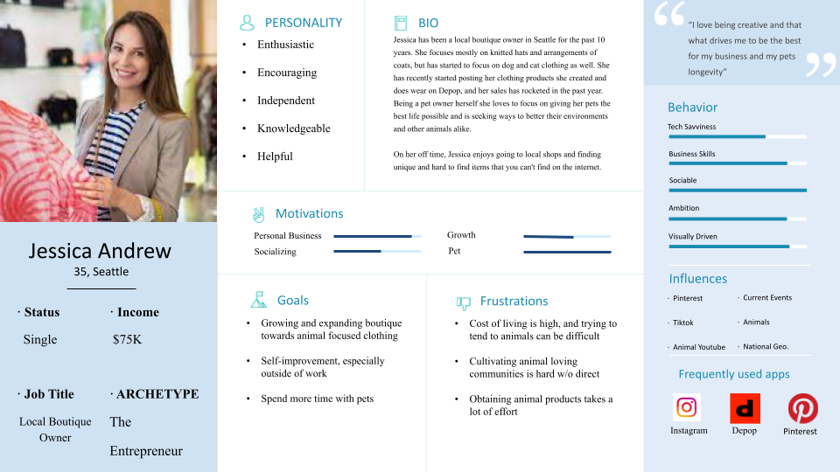

**Image 2: Persona (Buyer-based)**

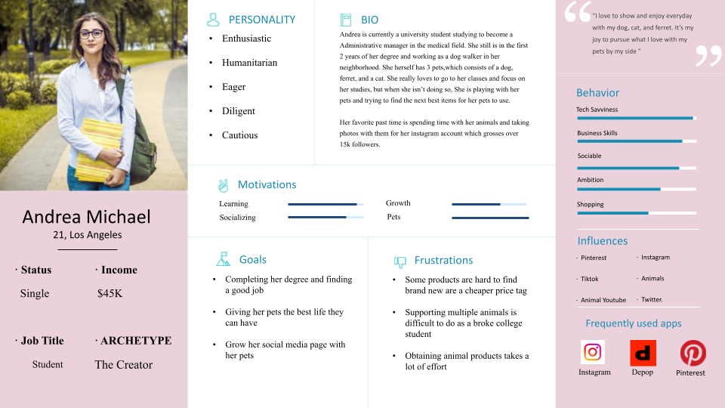

**Design Documents:**

**Domain Model:**

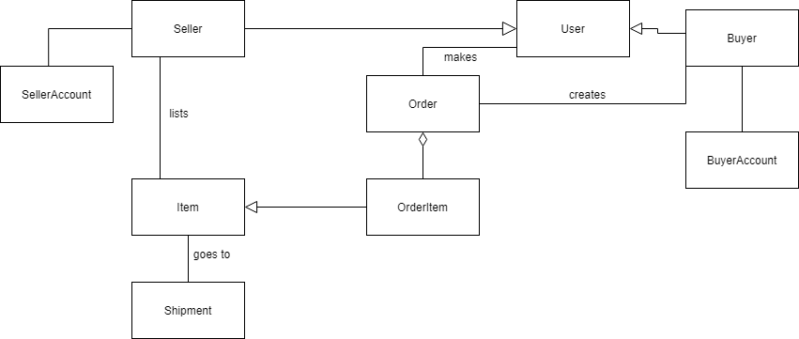

**Use Case Texts:**

Buyer: Purchase Item (Senario)

1. Buyer enters p2p site
2. Buyer clicks view listings of items
3. System processes Listings
4. Buyer adds item to cart after viewing
5. System validates if item is currently available
6. System retrieves for item listed in the public and seller list
7. Buyer completes purchase of Item found and retrieved in the Cart

Seller: Purchase Item (Senario)

1. Seller enters p2p site
2. Seller clicks sign up for seller rights
3. System processes seller for valid information logged
4. Seller confirms information that is stored on website
5. System initializes their user files and Item list for selling
6. System opens account page
7. Seller is presented to Account page listing items, current status, and options for account preferences

**Use Case:**

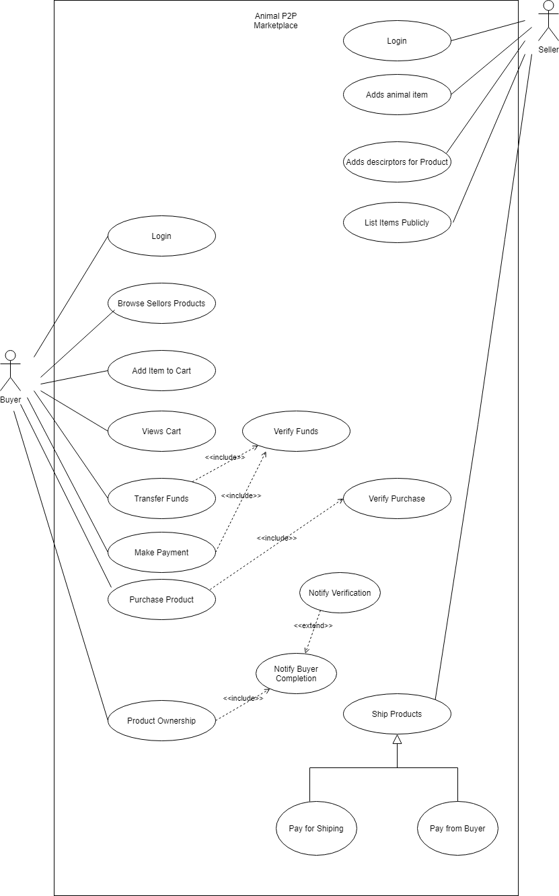

**Robustness Diagram (Buyer):**

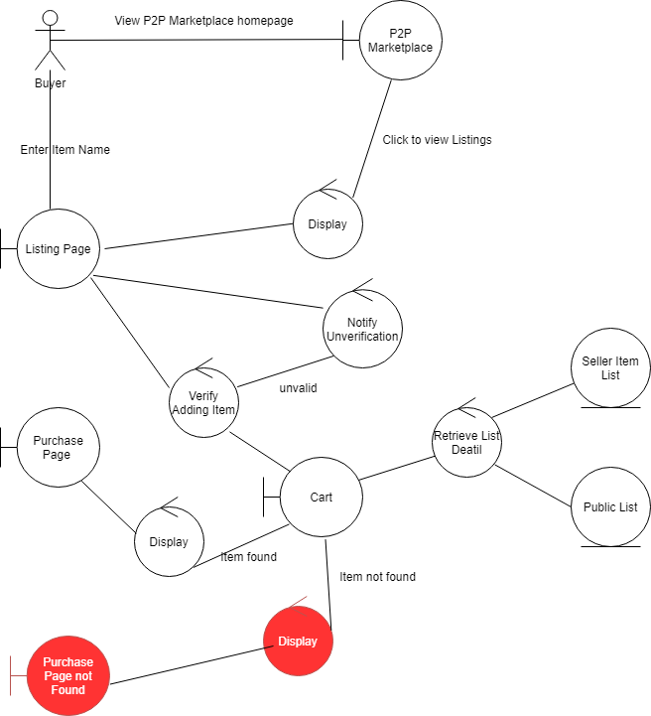

**Robustness Diagram (Seller):**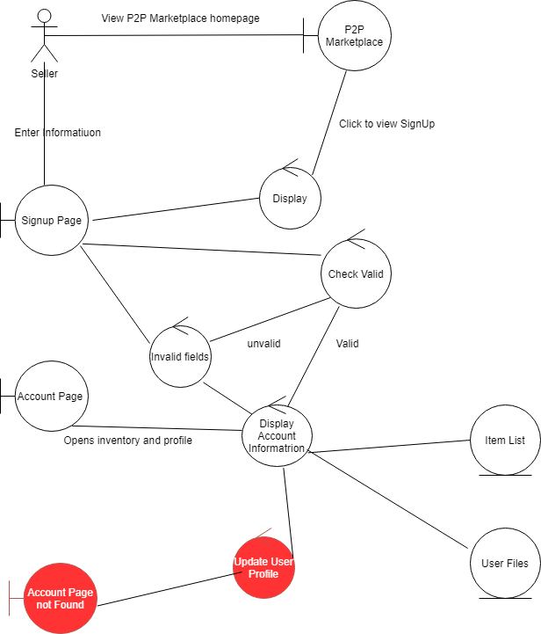

**Sequence Diagram (Buyer):**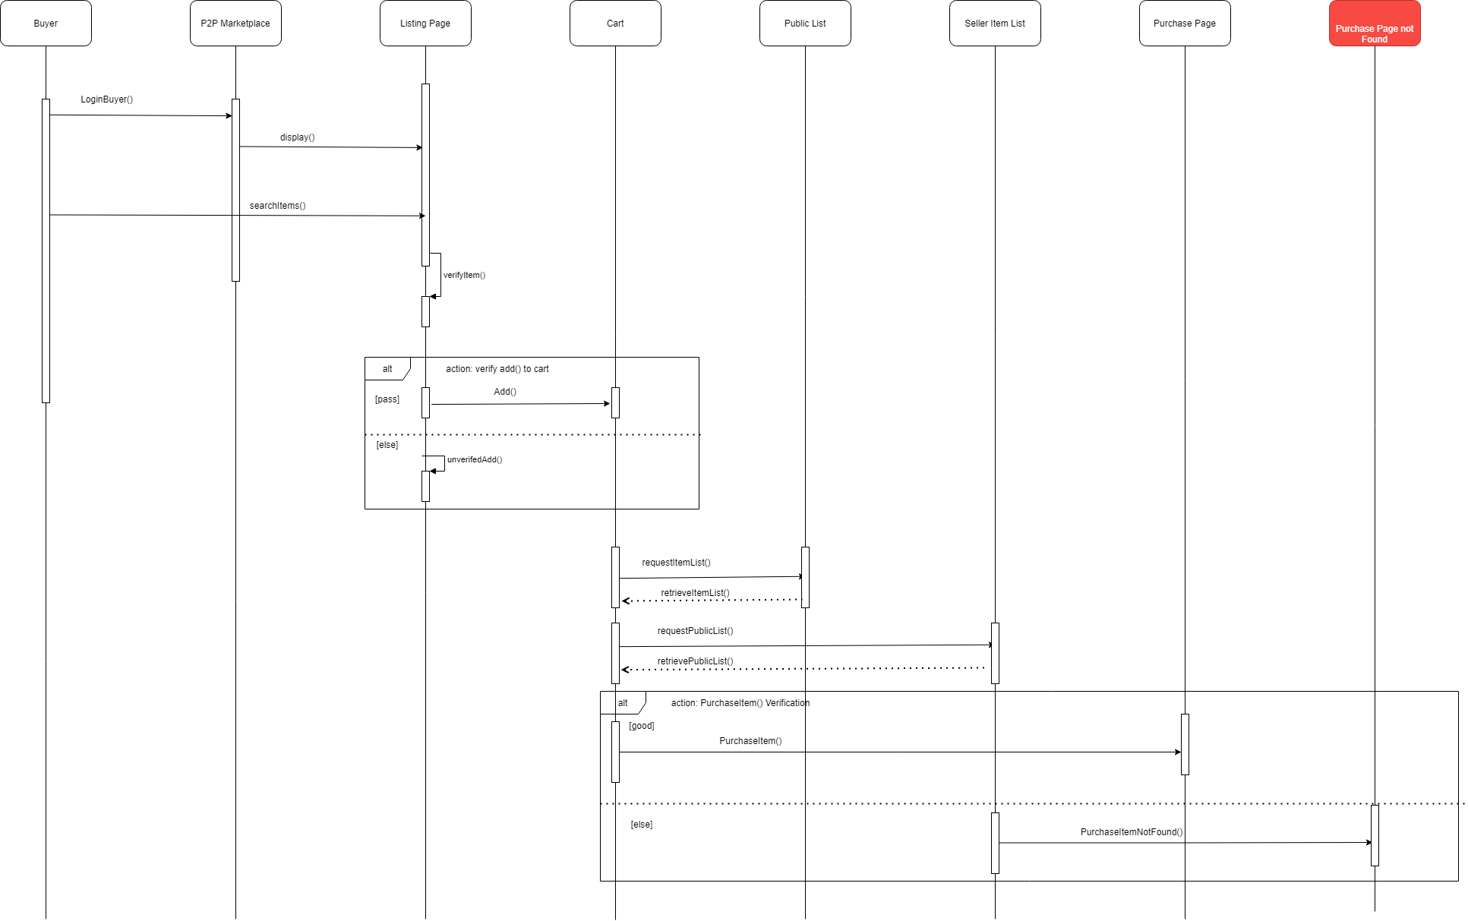

**Sequence Diagram (Seller):**

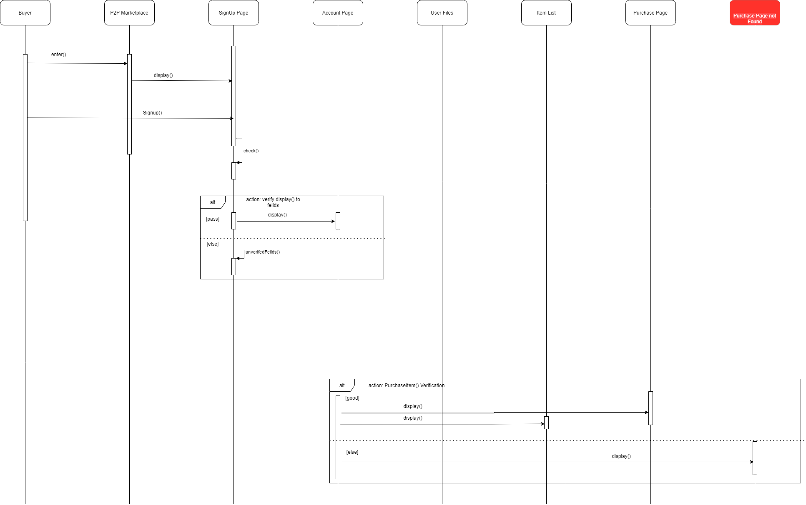

**Class Diagram:**

